Name : Pranali Sonawane
Subject : CCNA
Date: 10-10-25
Lab: Switch Configuration
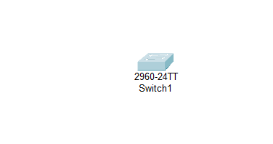
Switch> enable
Switch# configure terminal
Switch(config)# hostname Pranali
Pranali(config)# enable password admin123
Pranali(config)# exit
Pranali# show running-config
Pranali# configure terminal
Pranali(config)# service password-encryption
Pranali(config)# exit
Pranali# configure terminal
Pranali(config)# enable secret Pranali
Pranali(config)# exit
Pranali# show running-config
Pranali# reload

